**Semester 3: Practice Hands-on Exam**

**TOPOLOGY:**

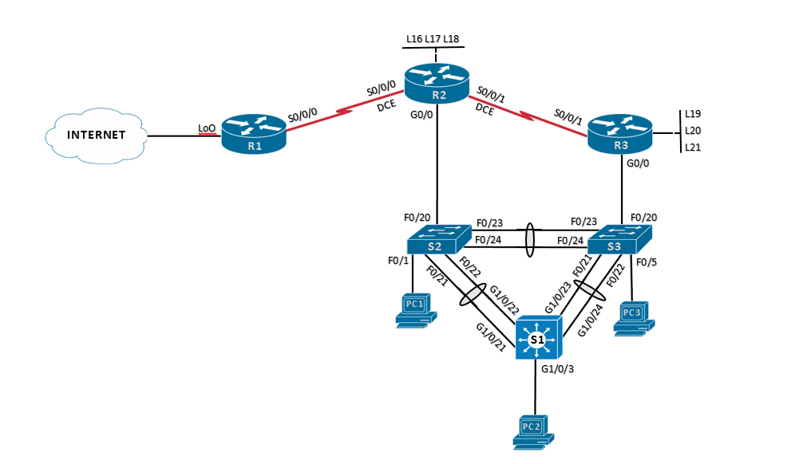

**Addressing Table**

|  |  |  |  |  |
| --- | --- | --- | --- | --- |
| Device | Interface | IP Address | Subnet Mask | Default Gateway |
| R1 | S0/0/0 | 10.56.100.1 | 255.255.255.252 | N/A |
| Lo0 | 200.200.109.225 | 255.255.255.248 | N/A |
| R2 | G0/0 | 10.56.0.252 | 255.255.255.0 | N/A |
| S0/0/0 | 10.56.100.2 | 255.255.255.252 | N/A |
| S0/0/1 | 10.56.100.5 | 255.255.255.252 | N/A |
| Lo16 | 10.56.16.1 | 255.255.255.0 | N/A |
| Lo17 | 10.56.17.1 | 255.255.255.0 | N/A |
| Lo18 | 10.56.18.1 | 255.255.255.0 | N/A |
| R3 | G0/0 | 10.56.0.253 | 255.255.255.0 | N/A |
| S0/0/1 | 10.56.100.6 | 255.255.255.252 | N/A |
| Lo19 | 10.56.19.1 | 255.255.255.0 | N/A |
| Lo20 | 10.56.20.1 | 255.255.255.0 | N/A |
| Lo21 | 10.56.21.1 | 255.255.255.0 | N/A |
| S1 | VLAN 1 | 10.56.0.240 | 255.255.255.0 | 10.56.0.254 |
| S2 | VLAN 1 | 10.56.0.241 | 255.255.255.0 | 10.56.0.254 |
| S3 | VLAN 1 | 10.56.0.243 | 255.255.255.0 | 10.56.0.254 |
| PC-A | NIC | 10.56.0.248 | 255.255.255.0 | 10.56.0.254 |
| PC-B | NIC | 10.56.0.249 | 255.255.255.0 | 10.56.0.254 |
| PC-C | NIC | 10.56.0.250 | 255.255.255.0 | 10.56.0.254 |

1. **Connect all devices per the topology diagram**
2. **Assign IP addresses, subnet mask and default gateways to all PCs (Refer to Addressing Table)**
3. **Configure basic settings Router 1, Router 2 and Router 3**
   1. Hostname (refer to topology)
   2. Disable DNS lookup
   3. Encrypted priv. exec. password class
   4. Console password cisco
   5. VTY password cisco
   6. MOTD banner “Unauthorized Access is Prohibited”
4. **Configure S1, S2 and S3**
   1. Hostname (refer to topology)
   2. Disable DNS lookup
   3. Encrypted priv. exec. password class
   4. Console password cisco
   5. VTY password cisco
   6. MOTD banner “Unauthorized Access is Prohibited”
   7. Add IP address and Subnet mask to default SVI (Refer to Addressing Table)
   8. Add default gateway (Refer to Addressing Table)
   9. Configure links between all switches as trunks
   10. Make all unused port access ports and shut down
5. **Configure the Layer 3 interfaces for R1, R2 and R3** 
   1. Configure LAN, WAN and Loopback Interfaces (Refer to Addressing Table)
   2. Add IP address, subnet mask, and description stating which device they connect to (Refer to Topology and Addressing Table)
   3. Activate all interfaces
6. **Configure Rapid PVST+ on all switches**
   1. Configure S2 as the secondary root bridge for VLAN 1
   2. Configure S3 as the primary root bridge for VLAN 1
   3. Configure PortFast and BPDU Guard on the interfaces connected to the PCs
7. **Configure HSRP on R2 and R3**
   1. Configure R3 as the primary HSRP router and make sure it retains the role as the primary router after reboot
   2. Use the virtual IP address of 10.56.0.254 and group number of 10
8. **Configure EtherChannel** 
   1. Configure EtherChannel group 4 between S2 and S3 without using a protocol
   2. Configure EtherChannel group 5 between S2 and S1 using PAGP with S2 initiating the negotiation and S1 only using PAGP if a PAGP device is detected
   3. Configure EtherChannel group 6 between S1 and S3 using LACP with S1 initiating the negotiation and S3 only using LACP if a LACP device is detected
9. **Configure EIGRP on R1, R2 and R3**
   1. Autonomous System number 20
   2. Router ID-R1: 1.1.1.1, R2: 2.2.2.2 and R3 3.3.3.3
   3. Advertise directly connected Networks using classless network addresses and wild card masks
   4. Advertise all Loopbacks except for the ISP
   5. Create a default route on the appropriate router and propagate it to all router in the topology
   6. Set bandwidth on all serial interfaces to 1024 KB/s
   7. Set the hello-interval to 20 seconds and the hold-time to 60 seconds on all serial interfaces
10. **Test connectivity on entire network** 
    1. From PC1, ping the Internet address, loopback addresses and the other PCs
11. **Test HSRP**
    1. Test functionality by disabling the forwarding router to make sure the standby router assumed the role as the forwarding router. Re-enable the forwarding router.

***Command References***

* What command will display all connected EIGRP routers?

* What command displays EIGRP hello-interval, hold-time and bandwidth percentage for all EIGRP interfaces on a router?

* What command displays STP configurations (root bridge ID, participating ports, port roles, priority) for a specific VLAN?

* What command displays a consolidated output (port channel ID, protocol, participating ports) for all configured etherchannels?

* What command displays detailed information about all currently configured HSRP groups?

* What command displays the size of an IOS image loaded on a network device

* What command displays the IOS image that is currently being used by the network device?

* What command displays the amount of space available to install an additional IOS image to a network device?